Azure Student Account Activation
Instructions for activating Azure Student Account for the "Containers and Clouds" course @ SoftUni

 | With the "Azure for Students" subscription that you have, you get $100 credit or 12 months (which is first exceeded) without requiring a credit card. If you exhaust your available credits, your Azure subscription will be disabled and you should upgrade.  For this reason, you should save your credits. To do this, make sure that you keep your Azure resources active for as little time as possible, e.g., delete the created resources when you don't need them anymore.

Explore Azure Portal
Azure Portal is a single portal to access and manage all your apps. You will need it when uploading and working with apps in Azure.
 | If you have a personal Azure account, don't use the phone number, that is associated with it, when activating your Azure student account! Instead, use another phone number in order for your activation to be successful.

Activate Azure Student Subscription
Before we do anything with Azure, you should activate your student subscription to be provided with free resources from Azure.
To do this, visit Azure Portal on https://azure.microsoft.com/en-us/free/students and click on the [Start free] button:
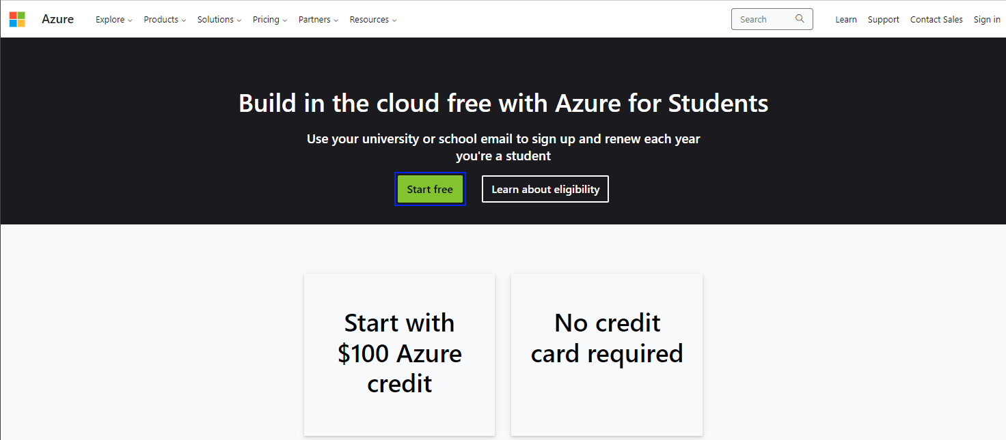

If You Have Another Azure Account
In case you have another Azure account, when you click on the [Start free] button, a login page will open and you will see it there. You should click on the Sign in with another account link:
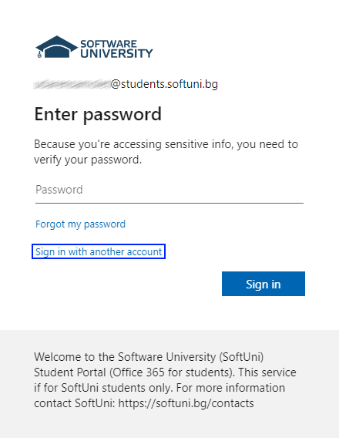
Choose Use another account from the displayed options:
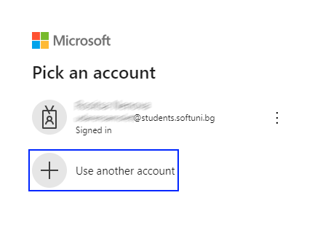
Type in your SoftUni DevOps student email and click on the [Next] button:
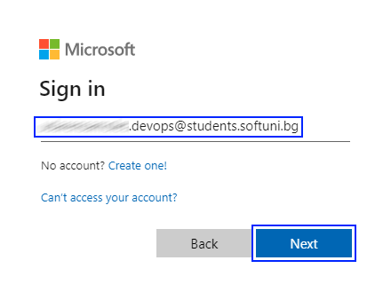
You will be asked to provide your password. Type it in and click on the [Sign in] button:
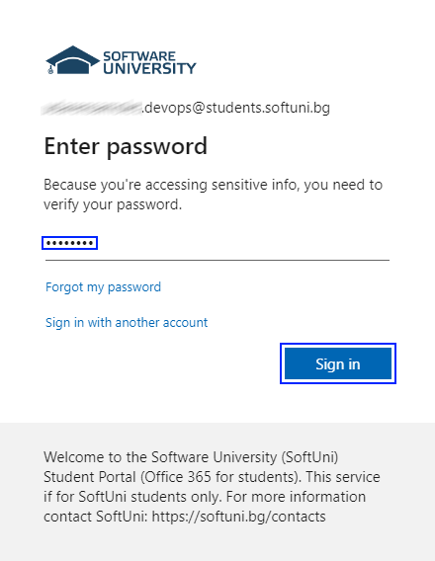
After that, you will be asked to create a new password. After you create your new password, click on the [Sign in] button again:
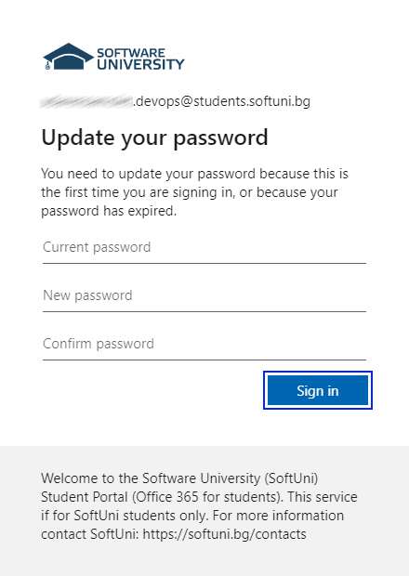
Then, you will be asked for some more information. Click on the [Next] button again:
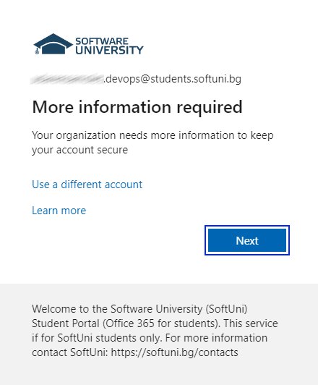
You will be asked for a phone number.
NOTE: Remember that you should use a different phone number from the one you have used for your other Azure account!
You will receive a 6-digit code, which you should enter and click on the [Next] button:
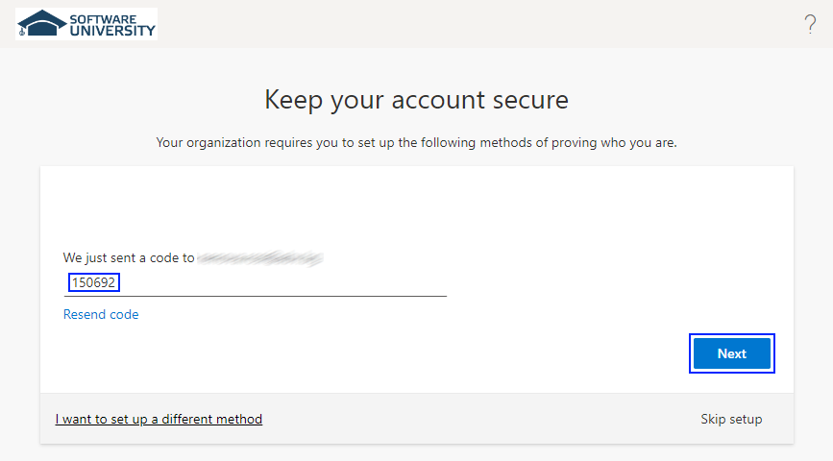
After that, you should see a success message. Click on the [Done] button:
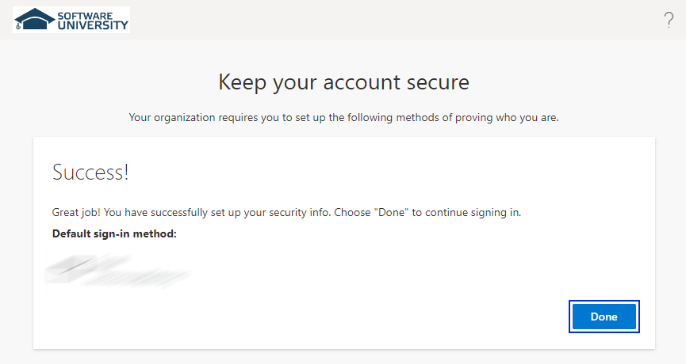
You will be asked for some more details. Provide the requested information. Please note that your names and your e-mail will be already present in the form – do not change them!
Don't fill in anything in the School name input field!
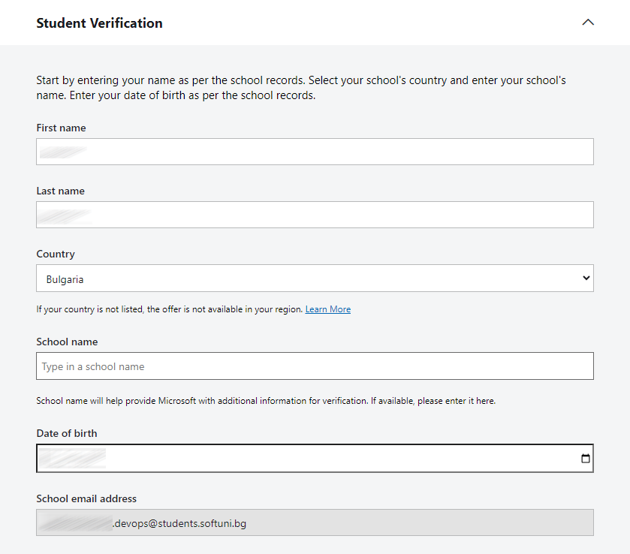
You may be asked to solve a puzzle to prove you're human – solve it and click on the [Verify academic status] button:
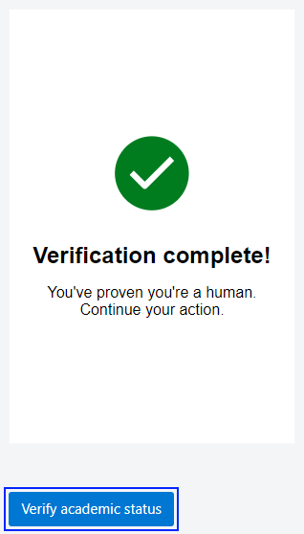
After that, a new window will appear and you will be asked to enter your first and last names, your address, you phone number and a second e-mail.
IMPORTANT NOTE: Please keep in mind that the phone number and e-mails should be different from the ones registered to your other Azure account!
After confirming your personal information, you will be redirected to the home page of the Azure Education Portal.
When login is successful, you will see the main page of the Azure Education Portal:
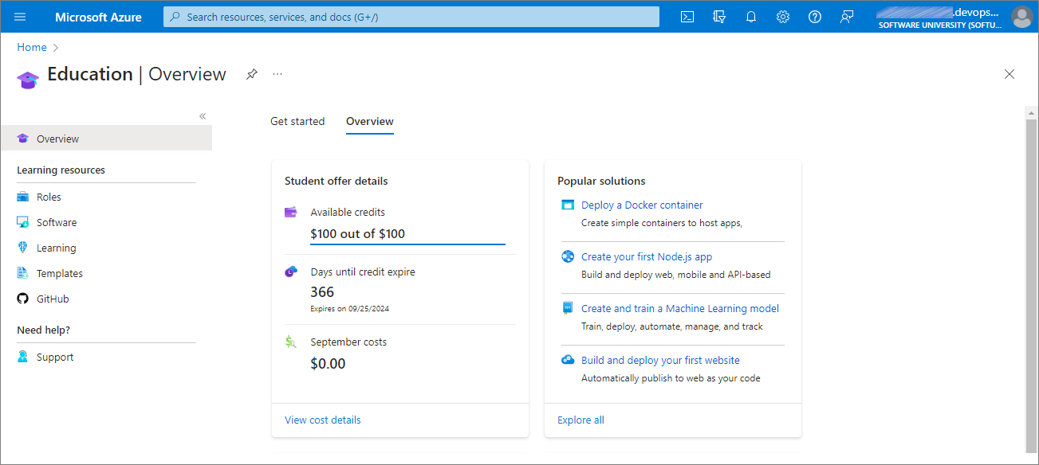
Congratulations! You have successfully activated your student Azure account!

If You Do Not Have Another Azure Account
If you don't have an Azure account already, when visiting the sign-in page, you should see the form from the image below. Click on the [Next] button
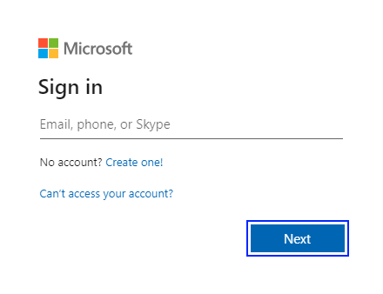
Input the password that you have been provided with and click on the [Sign in] button:

You will be asked to create a new password. Type the old one and the new one and click on the [Sign in] button:

After that, you will be asked for additional information – you should type in your phone number:
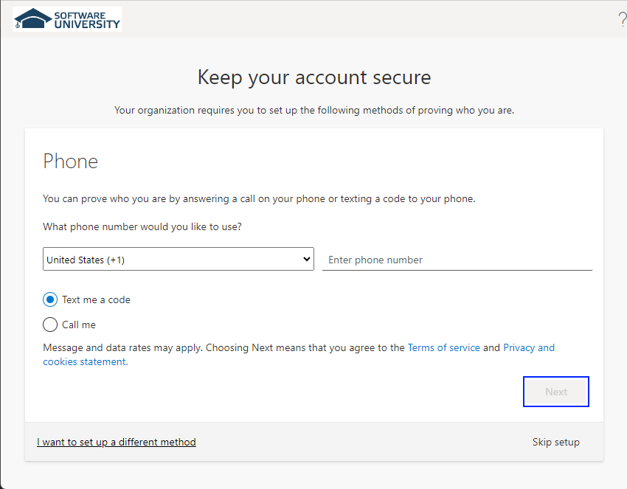
You will receive a 6-digit code, which you should enter and click on the [Next] button:

After that, you should see a success message. Click on the [Done] button:

You will be asked for some more details. Provide the requested information. Please note that your names and your e-mail will be already present in the form – do not change them!
Don't fill in anything in the School name input field!

You may be asked to solve a puzzle to prove you're human – solve it and click on the [Verify academic status] button:

After that, a new window will appear and you will be asked to enter your first and last names, your address, you phone number and a second e-mail.
After confirming your personal information, you will be redirected to the home page of the Azure Education Portal.
When login is successful, you will see the main page of the Azure Education Portal:

Congratulations! You have successfully activated your student Azure account!

